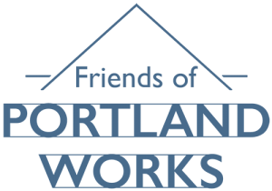

Friends of Portland Works

Charitable Incorporated Organisation
Charity Registration Number:
1160641 (England and Wales)
Report of the Trustees and Unaudited Financial Statements
Year ended 31 December 2025

www.friendsofportlandworks.org
Friends of Portland Works
Trustees’ Report
For the Year Ended 31 December 2025

The Trustees present their report with the financial statements of the Charity for the year ended 31 December 2025.
Reference and administrative information
Charity name: Friends of Portland Works
Charity Registration Number (England & Wales): 1160641
Registered Office: Portland Works
Randall Street
Sheffield
S2 4SJ

Trustees at 31 December 2025
Paul Iseard– Chairman
Carol Seymour – Membership Secretary
Janet Williams – Minutes secretary
Stella Howe – Education Adviser
John Clarke
Philip Martin
Christopher Cooper
Lynne Alleway

The Charity employs no staff, utilising volunteers where appropriate.

Bankers
CAF Bank Ltd, 25 Kings Hill Avenue, Kings Hill, West Malling, ME19 4JQ

Structure, governance and management
The Charity is a Charitable Incorporated Organisation (“CIO”), established on 25 February 2015. It is governed by its Constitution. If the CIO is wound up, members have no liability to it.

Recruitment and appointment of trustees
The management of the CIO is vested in the Trustees, who are elected by the membership and act in a voluntary capacity.
There is a minimum of three and a maximum of twelve trustees who are elected at the Annual General Meeting. Portland Works Little Sheffield Limited, Industrial and Provident Society number IP031143, (PWLS) may appoint up to eight charity trustees. No more than half of the appointed charity trustees may be directors of PWLS. By giving written notice to the CIO, the appointing body may reduce the number of nominated charity trustees it wishes to appoint, to a number less than eight. Once the number has been reduced, it may not subsequently be increased.
Business property management and community skills are well represented amongst the Trustees. New trustees are sought by open advertisement, or individuals are approached to offer themselves for election subject to the rights of PWLS.

Friends of Portland Works
Trustees’ Report
For the Year Ended 31 December 2025 - continued

OBJECTIVES

The objects of the CIO are to promote, for the benefit of the public, urban regeneration in areas of social and economic deprivation (and in particular in Sheffield and the surrounding area) by all or any of the following means:

- assisting in the preservation of buildings or sites of historic or architectural importance, and in protecting the built environment, in particular Portland Works (a Grade 2* listed building) and any similar building in Sheffield and the surrounding area;

- by assisting in the preservation of Portland Works and similar buildings, help to create training and employment opportunities through the provision of small workspace units, for rental on favourable terms;

- the advancement of education and helping to provide public access to Portland Works and similar buildings; also training or retraining, particularly among unemployed people, and providing unemployed people with work experience;

- such other means as may from time to time be determined subject to the prior written consent of the Charity Commissioners for England and Wales.

Statement of public benefit
The Trustees confirm they have complied with the duty in Section 4, Charities Act 2011, to have due regard to the guidance issued by the Charity Commission concerning public benefit.

ACTIVITIES

Trustees maintain a strong focus on fund raising through community engagement. The two activities go hand in hand as we promote the Works through our annual programme of lectures, attendance at events, visits and giving talks to Sheffield organisations.

Education and Outreach

The lecture programme continued in 2025 with 7 lectures held at Portland Works. The programme is designed to promote Sheffield’s social, economic, natural and industrial heritage. Ticket money is shared between FoPW and Portland Works Little Sheffield (PWLS) who provide the premises and equipment free of charge.

The lecture programme produced a surplus of over £1300 (£750 in ticket sales and £568 in raffle and refreshment income). For many attendees it was their first visit to Portland Works. Our best attended lecture of the year was Simon Ogden’s talk on the Rivers Sheaf and Porter.

Friends also promoted Portland Works at these outreach events throughout the year:

- Sheffield Heritage Fair
- Sheffield Fayre
- The Portland Works Open Day
- Kelham Island Christmas Market

Together these events generated over £2,200 from sales of donated goods, raffle tickets and membership sign-ups on the day. Trustees and volunteers made good use of these opportunities to engage with the Sheffield public and visitors to the city. By reaching out across Sheffield’s communities PWLS and Friends have achieved greater diversity in the mix of volunteers. This is important as the original cadre of volunteers is getting older and inevitably there have been several retirements. As new people join, the gender, age and ethnic balance is becoming more representative of Sheffield’s population.

We were delighted to work with Astrea Burngreave Primary School on a Key Stage 2 local studies initiative. Pupils learned about Harry Brearley’s collaboration with Ernest Stuart resulting in the world’s first stainless steel cutlery being made at the Works in 1914. Friends of Portland works facilitated the project with help from Portland Works and a £750.00 grant from Sheffield Church Burgesses. Some of the Church Burgesses grant paid for a coach trip so the pupils could visit the David Mellor showrooms and factory in Hathersage. We hope to run the project in other schools during 2026 and beyond.

A bid for £44k of Heritage Funding was submitted in October 2025 with a result expected in early 2026. A brief summary is below:
"Portland Works-Innovation through Time" is an ambitious heritage and community engagement project designed to help secure the future of Portland Works, one of Sheffield's most significant historic industrial sites. There are four interconnected strands in the project: Strand 1: Recording Heritage Crafts and specialist skills. The Works is home to a unique cluster of specialist artisans. Strand 2: Celebrating the volunteer community. Volunteers have been a key factor in the success of the Works since it came into community ownership. Strand 3: Documenting the Works' recent history. From 1968 to 2013. the Works was owned by a succession of landlords. Ensuring memories of tenants, workers and others are not lost to time. Strand 4: To bring the story of Portland Works to young people at Key Stage 2 (ages 7-11) and Key Stage 3 (ages 11-14), using the story of stainless steel cutlery as the catalyst.

Membership scheme

We are pleased to report the Membership has increased year on year:
2023 | 70
2024 | 116
2025 | 138

Membership is an important source of additional income and many members choose to make a donation in addition to the £10.00 annual fee. Subscriptions and donations generated over £2000 in 2025. Volunteers at Portland Works are granted free membership in recognition of the valuable work they do. During the year we arranged member visits to Parkwood Springs, the Northern General Hospital Heritage Centre, and Stocksbridge Museum. Members received regular newsletters and bulletins to keep them abreast of our events, lecture programme, and other matters of interest. Members qualify for discounted tickets to our lectures.

Future Plans

Friends of Portland Works work closely with the Portland Works Board, General Manager and Building Manager. During the year, thanks to the diligence of the Portland Works team, a major programme of repair and restoration work has been developed. The work is being costed and prioritised in order to inform future budgets and to identify funding shortfalls. Urgent work is needed on the following:

- Structural deflection to E Block
- E Block Fire escape
- G Block Fire escape
- Missing support column in C Block
Trustees have agreed to mount a major fund-raising campaign to support the replacement of the external staircase to the Forge roof (G Block fire escape). This is especially important for public access to the C Block roof which is a key aspect of tours.

FoPW is also funding the new window frames on the Randall Street elevation, being made on site and installed by volunteers; and the remaining work on the B Block windows, guttering, and brickwork.

As well as applying for external grants in 2026, Friends aims to increase income by diversifying its sales of donated goods. In addition to table top sales we aim to sell to a wider audience through the selective use of eBay and auction houses.

Trustees are also exploring how to acquire items made by R F Mosley and Co to supplement the collection held at Portland Works.

FINANCE

Form CC16a below sets out our financial dealings over the year. Designated funds are voted by trustees and can be re-assigned by trustees if priorities change. Restricted funds are derived from external grants with a specific purpose that cannot be re-assigned unless with permission of the grant giving body.

During 2025 net receipts of £6,044 (2024: £5255) were boosted by grant income of £7,250 (2024: nil.) Grants to PWLS amounted to £9781(2024: £2520)

We are grateful to have received the following grants during 2025:
£3,000 from the J G Graves Charitable Trust towards the restoration of B Block windows
£3,500 from the Sheffield Town Trust for new window frames to the basements of the Randall Street elevation
£750.00 from Sheffield Church Burgesses for the Astrea Education project.

The following grants were paid out to Portland Works during 2025:

 | Purpose of grant | Sums paid to PWLS 2025 | Total award
1/24 | B Block guttering replacement and C Block repointing | £3100 | £3100
2/24 | Replacement of roof to unit G15-3 | £2895 | £2895
3/24 | Architects fees for survey and design work | £ 600 | £600
4/24 | Repairs to external staircases | £ 950 | £950
1/25 | Refurbishment of B Block windows | £2236 | £3,500
Total |  | £9781 | £11045

The other grant awarded was £750.00 to fund the educational initiative with Astrea Academy Burngreave. £551.00 of the grant was spent during 2025.
Running costs of the Charity are tightly controlled and came in at just £617 in 2025. This mainly consists of subscriptions, insurances and rent/rates for a small storage unit at Portland Works.
Sales income was again boosted by sales of the pocket knives made by Michael May and fitted with old Mosley blades.
The Charity holds donated goods which are sold at events – these do not have a tangible asset value so are excluded from the accounts.



May 2026

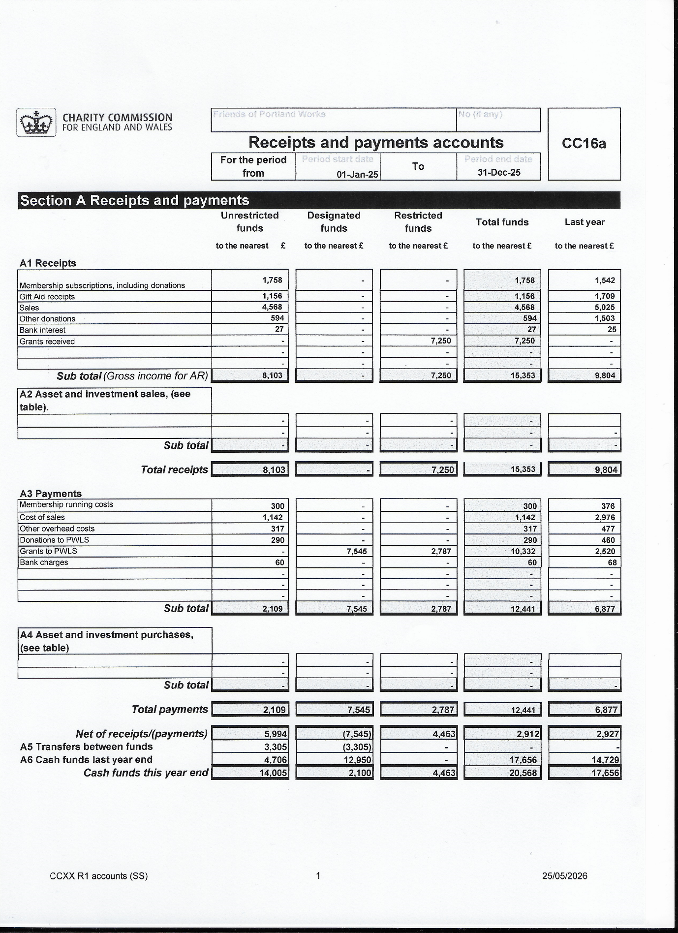

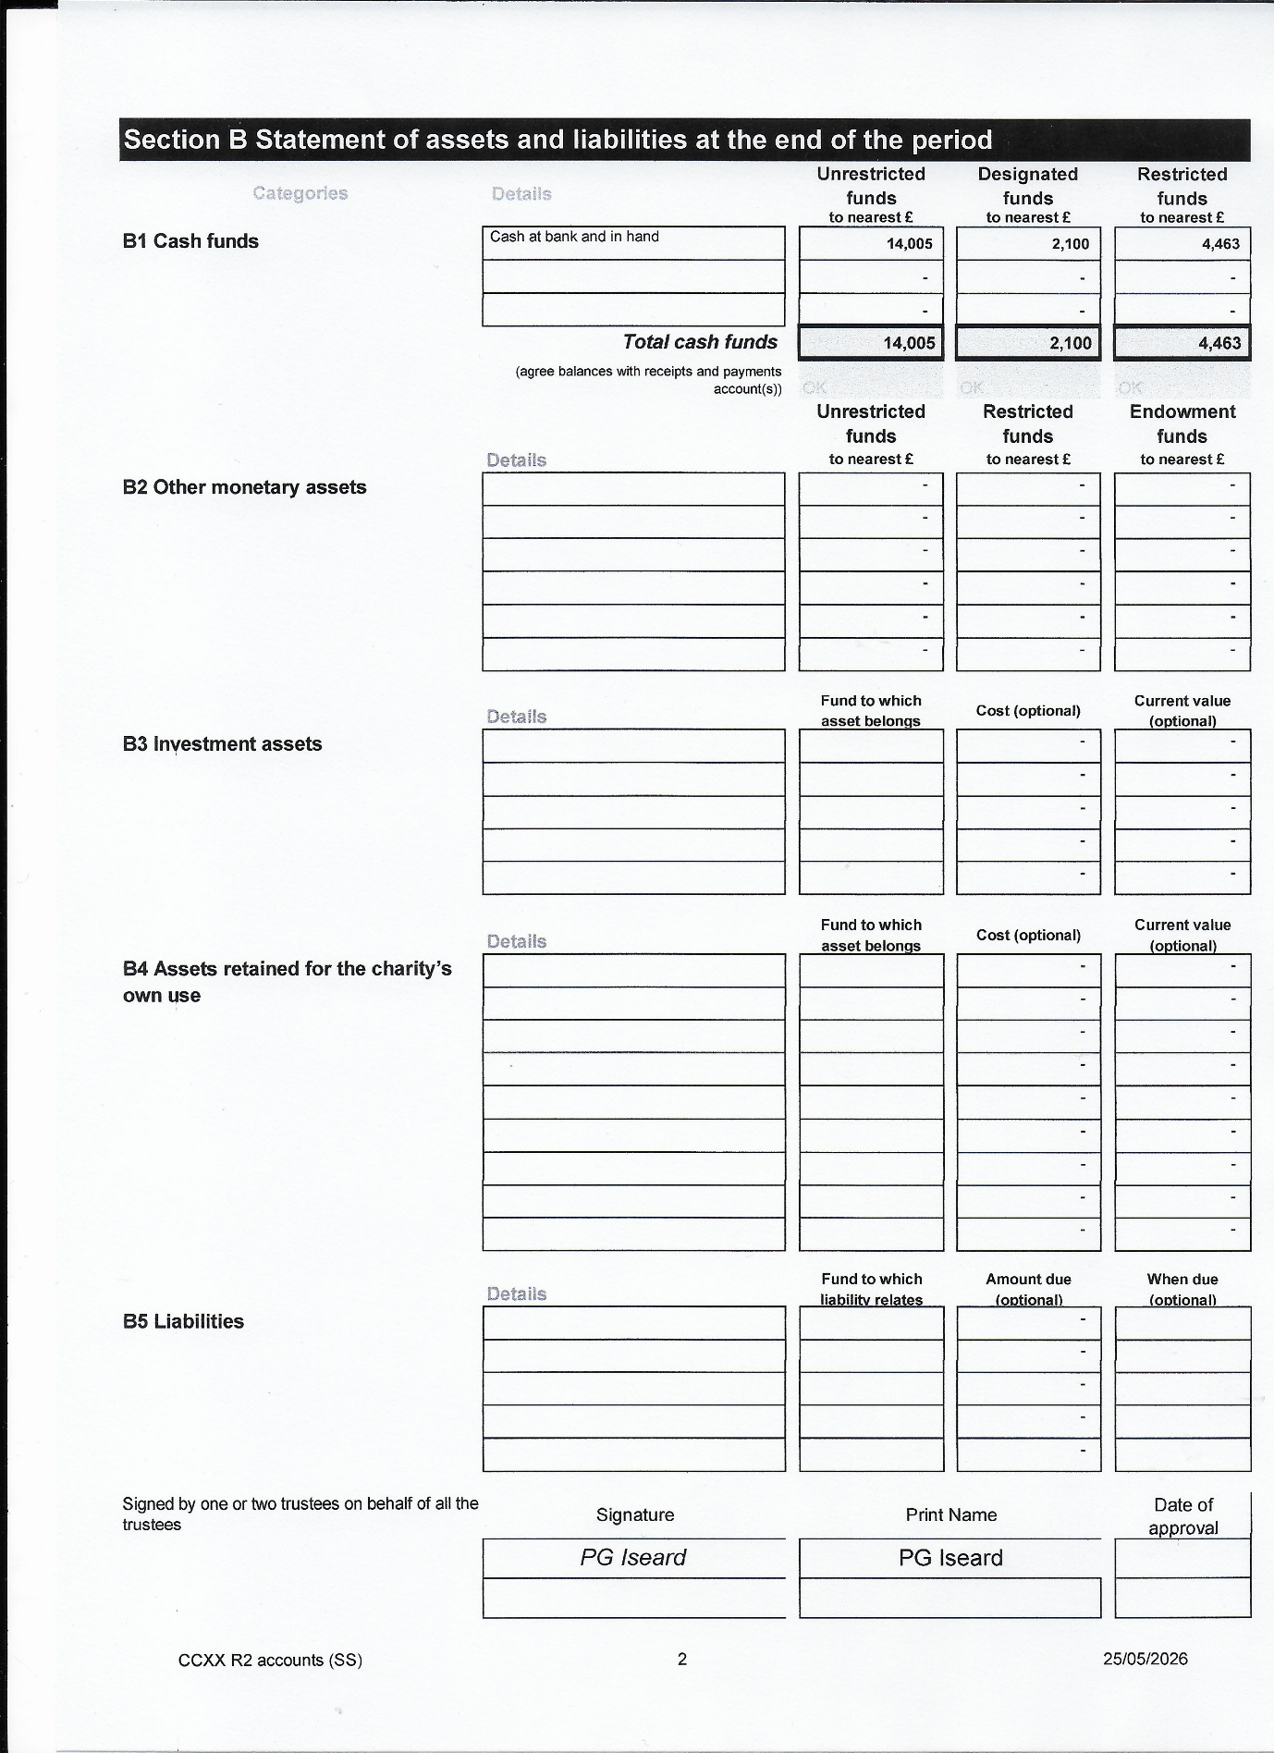

Notes to the financial statements
For the Year Ended 31 December 2025

(a) Basis of accounting
The financial statements have been prepared under the historical cost convention, the Statement of Recommended Practice: Accounting and Reporting by Charities preparing their accounts in accordance with the Financial Reporting Standard applicable in the UK and Republic of Ireland (FRS 102), applicable accounting standards and charity law.

The Charity constitutes a public benefit entity as defined by FRS 102.

- Fund accounting
- Unrestricted funds are available for use at the discretion of the Trustees in furtherance of the general objectives of the charity.
- Designated funds are the funds set aside by the Trustees out of unrestricted general funds for specific purposes or projects.
- Restricted funds are subjected to restrictions on their expenditure by the donor or through the terms of an appeal.

(c)Accounting policies

Recognition of Income
(a) Income is included in the Statement of Financial Activities (SoFA) when the Charity is legally entitled to the income and the monetary value can be measured with sufficient reliability.
- There has been no offsetting of assets and liabilities, or income and expenses, unless required by the FRS 102 SORP or FRS 102.
- Donations received are accounted for in the period in which they are received and are disclosed in the funds in accordance with the donor's wishes.
- Grants receivable are accounted for in the period in which they arise and are allocated to the funds for which they were donated. In the case of performance-related grants, income is only recognised to the extent that the Charity has provided the specified goods or services, as entitlement to the grant only occurs when the performance-related conditions are met.
- Gift Aid receivable is included in income when there is a valid declaration from the donor. Any Gift Aid amount recovered on a donation is considered to be part of that gift and is treated as an addition to the same fund as the initial donation unless the donor or the terms of the appeal have specified otherwise.
- The value of any voluntary help received is not included in the accounts but is described in the trustees’ annual report.

Resources expended
- Liabilities are recognised where it is more likely than not that there is a legal or constructive obligation committing the Charity to pay out resources and the amount of the obligation can be measured with reasonable certainty.
- Where the Charity gives a grant with conditions for its payment being a specific level of service or output to be provided, such grants are only recognised in the SoFA once the recipient of the grant has provided the specified service or output.
- Where there are no conditions attaching to the grant that enable the donor charity to realistically avoid the commitment, a liability for the full funding obligation is recognised.
- No material item of deferred income has been included in the accounts.

May 2026

